CSA0593

DATABASE MANAGEMENT SYSTEM.

NAME : S.DEEPIKA

REG NO. : 192324269

ASSIGNMENT – 3

**Design a database to manage movies, series, directors, and user watchlists.**

* **Model tables for movies, series, directors, genres, and watchlists.**
* **Write stored procedures for adding movies or series to user watchlists and recording user ratings.**
* **Implement triggers to update view counts and movie rankings based on ratings or watch count.**
* **Write SQL queries to analyse movie/series popularity, director ratings, and user viewing habits.**

**Design a database to manage movies, series, directors, and user watchlists**

**Entity-Relationship Model (ER Diagram)**

To design a **database for managing movies, series, directors, and user watchlists**, we will identify the **entities** and their **relationships** in tabular form. The entities include **Movies**, **Series**, **Episodes**, **Directors**, **Users**, and **Watchlists**.

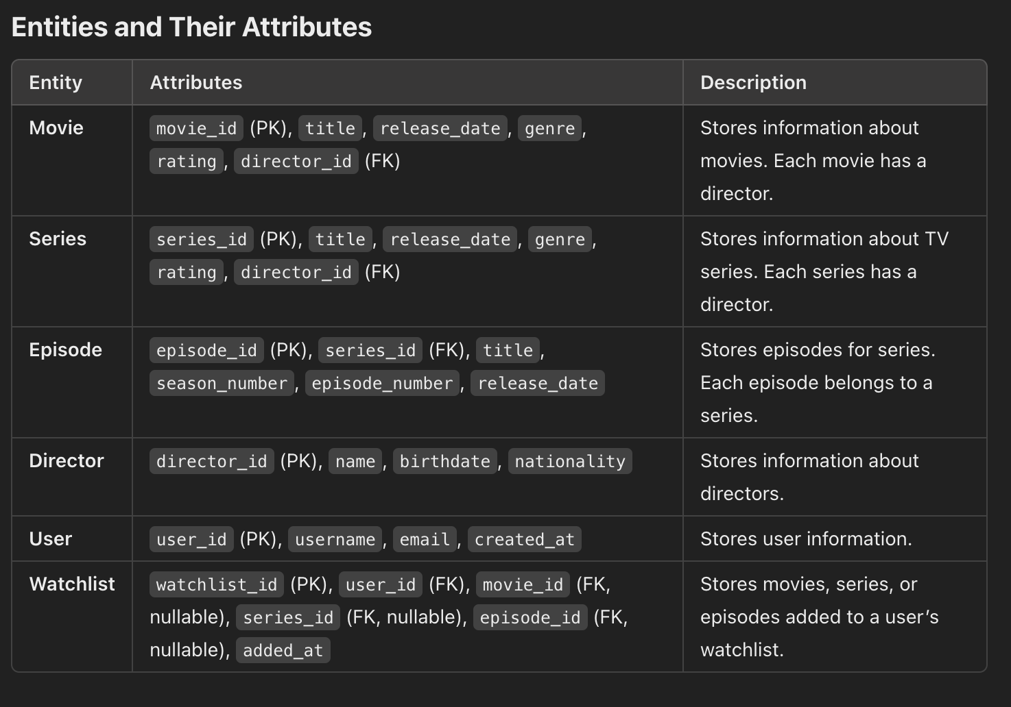

1. **Model tables for movies, series, directors, genres, and watchlists**

**1. Movies Table**

This table will store information specific to individual movies.

CREATE TABLE Movies (

movie_id INT PRIMARY KEY AUTO_INCREMENT,

title VARCHAR(255) NOT NULL,

release_date DATE,

director_id INT,

genre_id INT,

duration INT,

language VARCHAR(50),

rating DECIMAL(3, 1),

FOREIGN KEY (director_id) REFERENCES Directors(director_id),

FOREIGN KEY (genre_id) REFERENCES Genres(genre_id)

);

### 2. ****Series Table****

This table will store information for TV series, including the number of seasons.

CREATE TABLE Series (

series_id INT PRIMARY KEY AUTO_INCREMENT,

title VARCHAR(255) NOT NULL,

release_date DATE,

director_id INT,

genre_id INT,

seasons INT,

language VARCHAR(50),

rating DECIMAL(3, 1),

FOREIGN KEY (director_id) REFERENCES Directors(director_id),

FOREIGN KEY (genre_id) REFERENCES Genres(genre_id)

);

### 3. ****Directors Table****

This table will store information about directors.

CREATE TABLE Directors (

director_id INT PRIMARY KEY AUTO_INCREMENT,

name VARCHAR(255) NOT NULL,

birth_date DATE,

nationality VARCHAR(100)

);

### 4. ****Genres Table****

This table will store the different genres for movies or series.

CREATE TABLE Genres (

genre_id INT PRIMARY KEY AUTO_INCREMENT,

name VARCHAR(100) NOT NULL

);

### 5. ****Watchlists Table****

This table will store user-specific watchlists, where users can add movies or series they plan to watch.

CREATE TABLE Watchlists (

watchlist_id INT PRIMARY KEY AUTO_INCREMENT,

user_id INT

movie_id INT,

series_id INT,

added_on TIMESTAMP DEFAULT CURRENT_TIMESTAMP,

FOREIGN KEY (user_id) REFERENCES Users(user_id),

FOREIGN KEY (movie_id) REFERENCES Movies(movie_id),

FOREIGN KEY (series_id) REFERENCES Series(series_id)

);

**b.)** **Write stored procedures for adding movies or series to user watchlists and recording user ratings :**

### 1. Stored Procedure for Adding Movies or Series to User Watchlist

This procedure adds a specified movie or series to a user’s watchlist by inserting a record in the Watchlist table.

DELIMITER //

CREATE PROCEDURE AddToWatchlist(

IN p_user_id INT,

IN p_media_id INT,

IN p_media_type ENUM('movie', 'series')

)

BEGIN

IF EXISTS (SELECT 1 FROM Watchlist WHERE user_id = p_user_id AND media_id = p_media_id AND media_type = p_media_type) THEN

SIGNAL SQLSTATE '45000' SET MESSAGE_TEXT = 'This item is already in the watchlist.';

ELSE

INSERT INTO Watchlist (user_id, media_id, media_type, added_date)

VALUES (p_user_id, p_media_id, p_media_type, NOW());

END IF;

END //

DELIMITER ;

### 2. Stored Procedure for Recording User Ratings

This procedure allows users to rate movies or series by inserting or updating a rating in the Ratings table.

DELIMITER //

CREATE PROCEDURE RecordUserRating(

IN p_user_id INT,

IN p_media_id INT,

IN p_media_type ENUM('movie', 'series'),

IN p_rating DECIMAL(2, 1)

)

BEGIN

IF p_rating < 1.0 OR p_rating > 5.0 THEN

SIGNAL SQLSTATE '45000' SET MESSAGE_TEXT = 'Rating must be between 1.0 and 5.0.';

ELSE

IF EXISTS (SELECT 1 FROM Ratings WHERE user_id = p_user_id AND media_id = p_media_id AND media_type = p_media_type) THEN

UPDATE Ratings

SET rating = p_rating, rated_date = NOW()

WHERE user_id = p_user_id AND media_id = p_media_id AND media_type = p_media_type;

ELSE

INSERT INTO Ratings (user_id, media_id, media_type, rating, rated_date)

VALUES (p_user_id, p_media_id, p_media_type, p_rating, NOW());

END IF;

END IF;

END //

DELIMITER ;

**c.) Implement triggers to update view counts and movie rankings based on ratings or watch count :**

### 1. Trigger to Update View Count

This trigger updates the view count of a movie or series whenever it is added to a user’s watchlist. Each addition to the watchlist indicates that the movie or series has been "viewed" or "interested," so we increment the view count accordingly.

DELIMITER //

CREATE TRIGGER UpdateViewCount

AFTER INSERT ON Watchlist

FOR EACH ROW

BEGIN

IF NEW.media_type = 'movie' THEN

UPDATE Movies

SET view_count = view_count + 1

WHERE movie_id = NEW.media_id;

ELSEIF NEW.media_type = 'series' THEN

UPDATE Series

SET view_count = view_count + 1

WHERE series_id = NEW.media_id;

END IF;

END //

DELIMITER ;

### 2. Trigger to Update Movie Ranking Based on Ratings

This trigger recalculates the ranking of a movie or series whenever a new rating is added or an existing rating is updated. Rankings could be based on the average rating or total rating score for each movie or series.

DELIMITER //

CREATE TRIGGER UpdateMovieRanking

AFTER INSERT ON Ratings

FOR EACH ROW

BEGIN

DECLARE avg_rating DECIMAL(2, 1);

IF NEW.media_type = 'movie' THEN

SELECT AVG(rating) INTO avg_rating

FROM Rating

WHERE media_id = NEW.media_id AND media_type = 'movie';

UPDATE Movies

SET average_rating = avg_rating

WHERE movie_id = NEW.media_id;

ELSEIF NEW.media_type = 'series' THEN

SELECT AVG(rating) INTO avg_rating

FROM Ratings

WHERE media_id = NEW.media_id AND media_type = 'series';

UPDATE Series

SET average_rating = avg_rating

WHERE series_id = NEW.media_id;

END IF;

END //

DELIMITER ;

**d.) Write SQL queries to analyse movie/series popularity, director ratings, and user viewing habits:**

### 1. Analysing Movie/Series Popularity

This query retrieves the most popular movies or series based on view count and average rating. The result is ordered by view count and average rating in descending order.

SELECT

media_id,

title,

media_type,

view_count,

average_rating

FROM

(

SELECT movie_id AS media_id, title, 'movie' AS media_type, view_count, average_rating

FROM Movies

UNION ALL

SELECT series_id AS media_id, title, 'series' AS media_type, view_count, average_rating

FROM Series

) AS MediaPopularity

ORDER BY

view_count DESC,

average_rating DESC

LIMIT 10;

### 2. Analysing Director Ratings

This query calculates the average rating for each director based on the movies or series they directed. It provides insights into directors' performance by aggregating the ratings of their directed media.

SELECT

d.director_id,

d.name AS director_name,

AVG(r.rating) AS average_rating

FROM

Directors d

JOIN

Movies m ON d.director_id = m.director_id

JOIN

Ratings r ON m.movie_id = r.media_id AND r.media_type = 'movie'

GROUP BY

d.director_id, d.name

UNION ALL

SELECT

d.director_id,

d.name AS director_name,

AVG(r.rating) AS average_rating

FROM

Directors d

JOIN

Series s ON d.director_id = s.director_id

JOIN

Ratings r ON s.series_id = r.media_id AND r.media_type = 'series'

GROUP BY

d.director_id, d.name

ORDER BY

average_rating DESC;

### 3. Analysing User Viewing Habits

This query examines user viewing habits by counting the number of movies and series each user has added to their watchlist. It helps in understanding user preferences for movies or series.

SELECT

w.user_id,

u.name AS user_name,

SUM(CASE WHEN w.media_type = 'movie' THEN 1 ELSE 0 END) AS movies_watched,

SUM(CASE WHEN w.media_type = 'series' THEN 1 ELSE 0 END) AS series_watched,

COUNT(*) AS total_watched

FROM

Watchlist w

JOIN

Users u ON w.user_id = u.user_id

GROUP BY

w.user_id, u.name

ORDER BY

total_watched DESC;

**CONCLUSION :**

The SQL queries provided enable comprehensive analysis of a movie and series database, focusing on key aspects such as content popularity, director performance, and user viewing habits. By examining view counts, average ratings, and genre preferences, the queries offer valuable insights into what drives user engagement and highlights the top-rated and most-watched content. These analyses can inform content recommendations, platform optimizations, and strategic decisions for enhancing user experience and boosting media engagement.